**CentroMotion Dependent Scholarship Program**

**Applicant Guide**

* Part I. Summary of Application Process – brief description of the application process
* Part II. How to Start Your Application – detailed description of every step *before* you apply
* Part III. How to Complete You Application – screen shots and overview

Application Process

1. Apply here: <https://learnmore.scholarsapply.org/centromotion/>

Review eligibility, award and required documents information for the scholarship.

2. Create your Profile

Enter your email and create a password. (You will be redirected here once you click the “Scholarship America Hub” button on the bottom of the main page). After verifying your account, you will fill in basic information about yourself. Fill this in as completely and as accurately as you can.

3. Apply for CentroMotion Dependent Scholarship Program.

Once your profile is created, you will have access to applying to the scholarship program and perhaps other scholarships you may be eligible for.

4. Review and submit your application

Part II. How to Start Your Application

This is a brief guide to help you navigate through the beginning stages of the application process for the **CentroMotion Dependent Scholarship Program**. If you have read the guide and still have questions, you may contact Scholarship America at (507) 931-1682 and refer to the **CentroMotion Dependent Scholarship Program** or send an email to centromotion@scholarshipamerica.org.

First, the link provided to you (<https://learnmore.scholarsapply.org/centromotion/>) will take you to the landing page (**see screenshot below**), where you can review the eligibility requirements, award information, and required documents. Once you have read the landing page, you may click “Scholarship America Hub”.

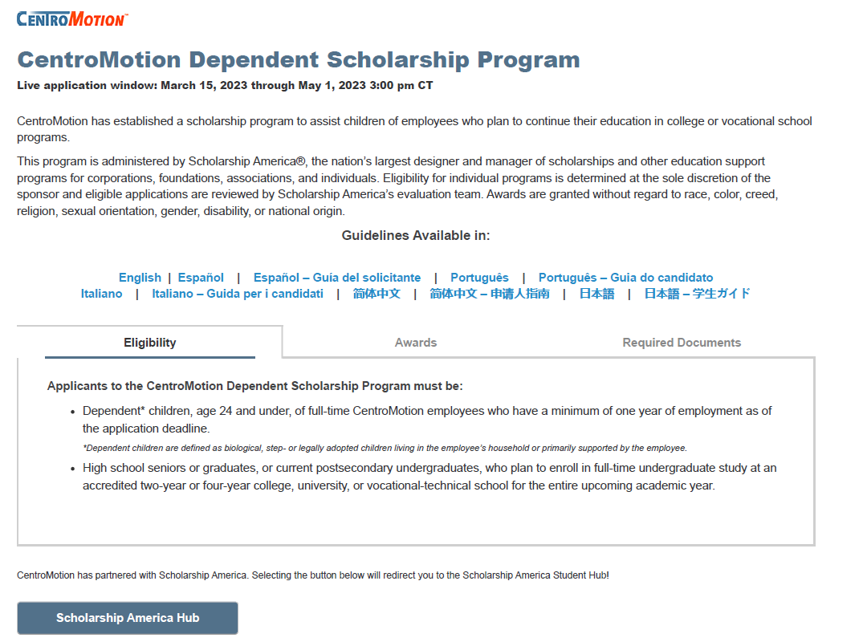

This will take you to the Scholarship America Hub login page (**see screenshot below**).

If you are first-time user of the Hub, click “I am student”.

*Note: Once you have an account, you will just sign in.

Once you click “I am student” and it is your first time here, click “No account? Create one” (**see screenshot below**).

Check your email account for a message from Scholarship America (account-security-noreply@accountprotection.microsoft.com) and enter the account verification code.

After entering your code, create your password (**see screenshot below**).

*Note: If you forget your username or password any time after this you complete this step, you can go to the login page and click “Forgot password/username?” for help.

After you create your password, you will return to the login screen.

After logging in, you will be asked to create a profile which includes all the basic information required for applications in the Scholarship America Hub (**see screenshot below**). This profile will be used to match you to other scholarship opportunities, if applicable.

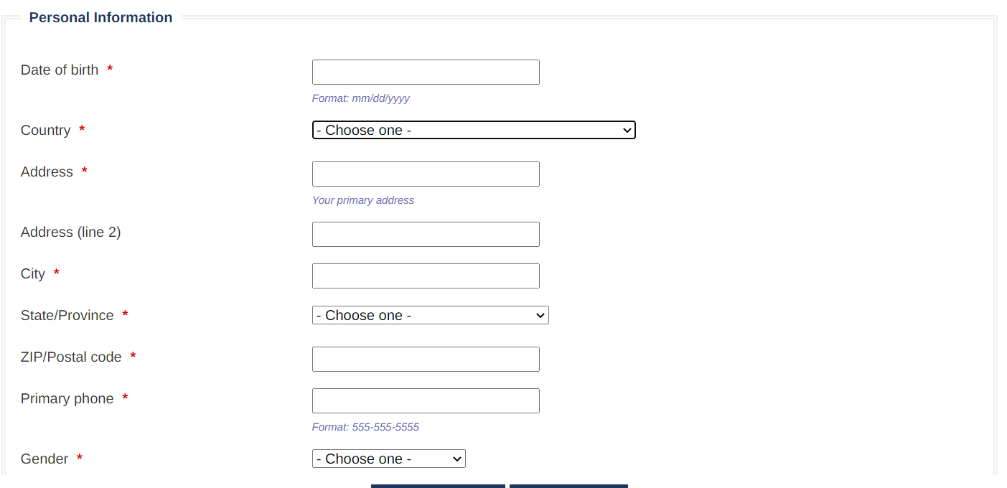

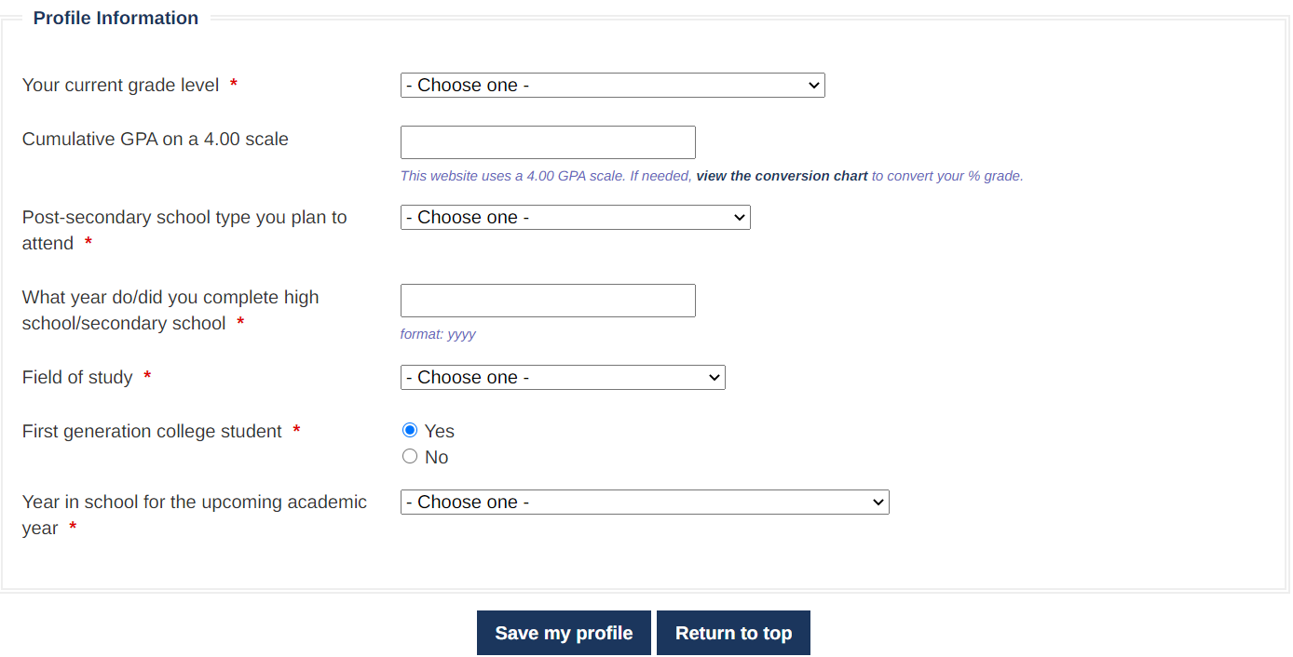

Once you have saved your profile, you will be sent to the Eligible Scholarships page (**see screenshot below**). Your program should be listed at the top of the page. Click APPLY NOW.

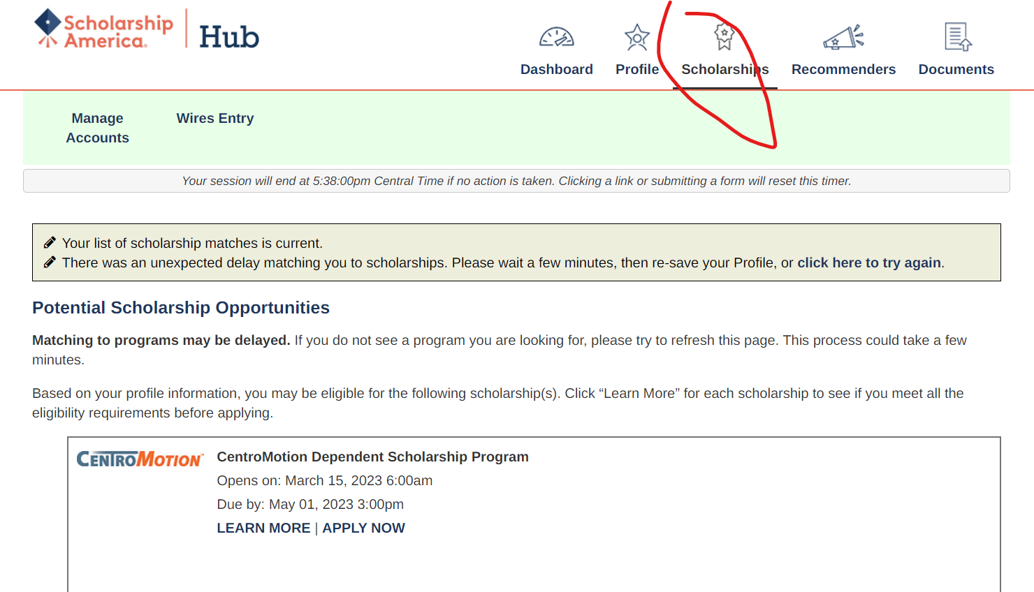*Note: LEARN MORE will take you back to the original landing page if at any time you would like to review the eligibility requirements, award information or list of required documents again.

After starting an application, anytime you return to the website, you can find your application here:

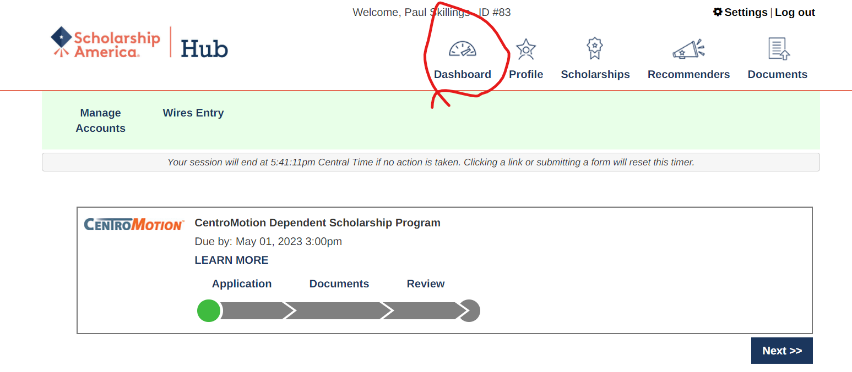

Click any section on the progress bar to complete unfinished portions of your application.

For example, “Application.”

**Part III. How to Complete You Application**

**Employee Parent or Guardian Information**

In this section, an applicant should provide the CentorMotion employee’s information.

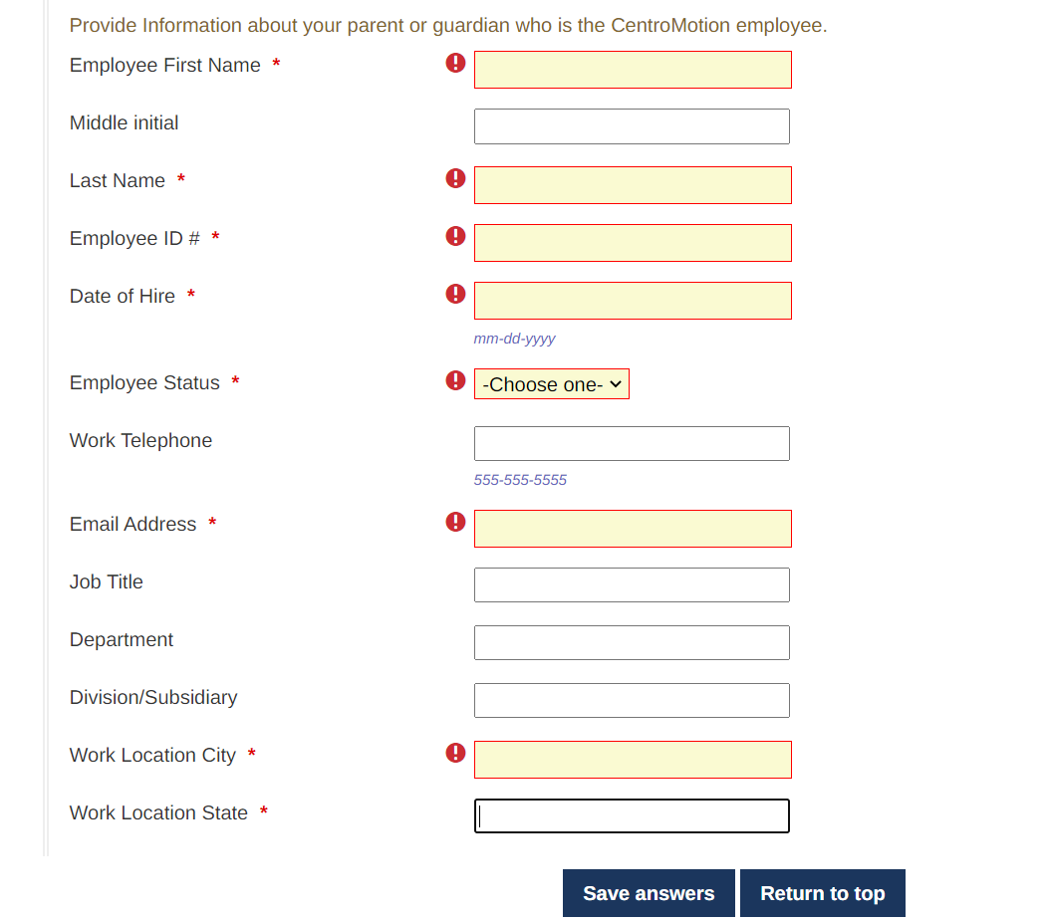

We recommend that you save your progress often.

**High School/Secondary School Information**

In this section enter your high school or upper secondary school information.

The last four questions are for students in the U.S. only.

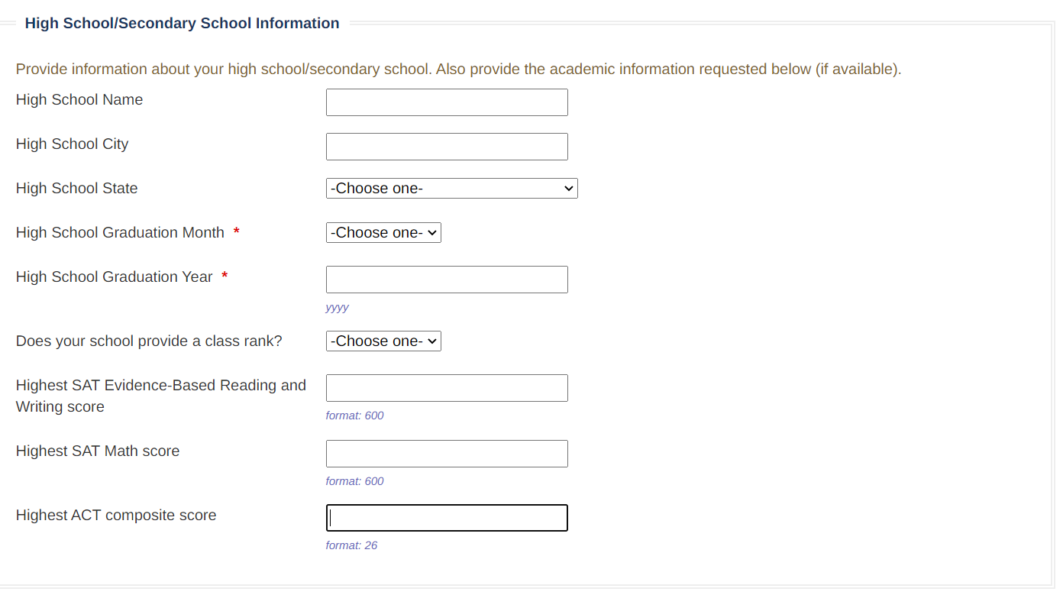

**Postsecondary School Information**

In this section, enter the college or university you will attend.

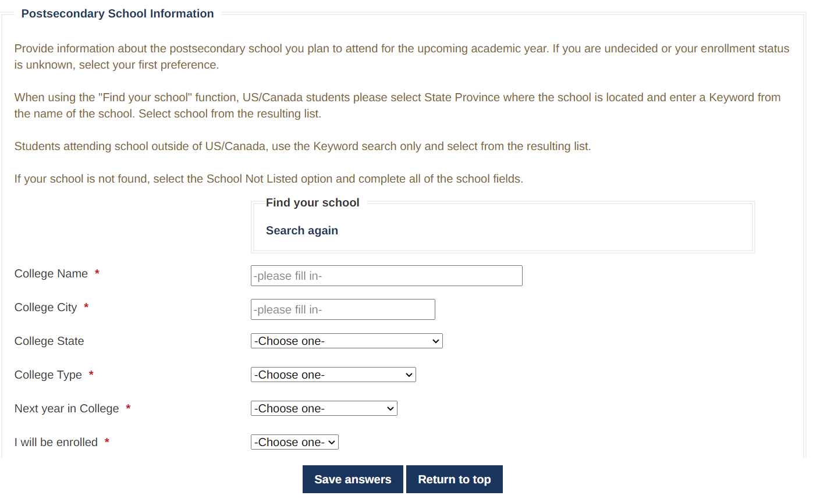

**Students attending school outside of US/Canada, use the Keyword search only and select from the resulting list.**

**If your college or university is not found, select the “School Not Listed” option and complete all of the school fields.**

**Work Experience**

* In this section, enter any jobs you have had. You can leave this space blank if it does not apply.

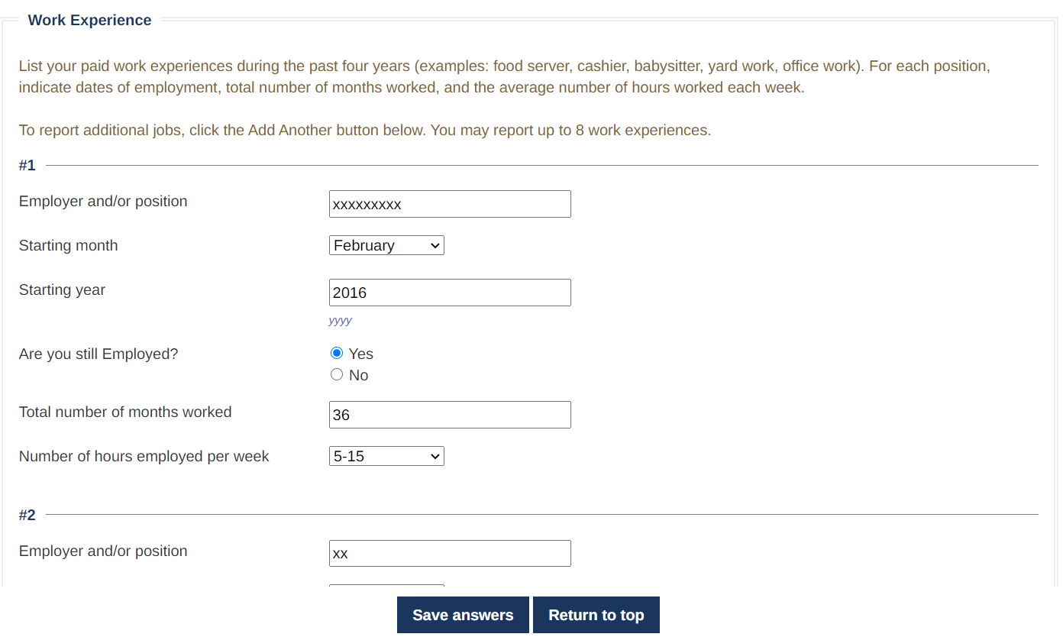

**Activities**

* In this section, enter any activities, for example sports, academic competitions, or volunteering in your community. You can leave this space blank if it does not apply.

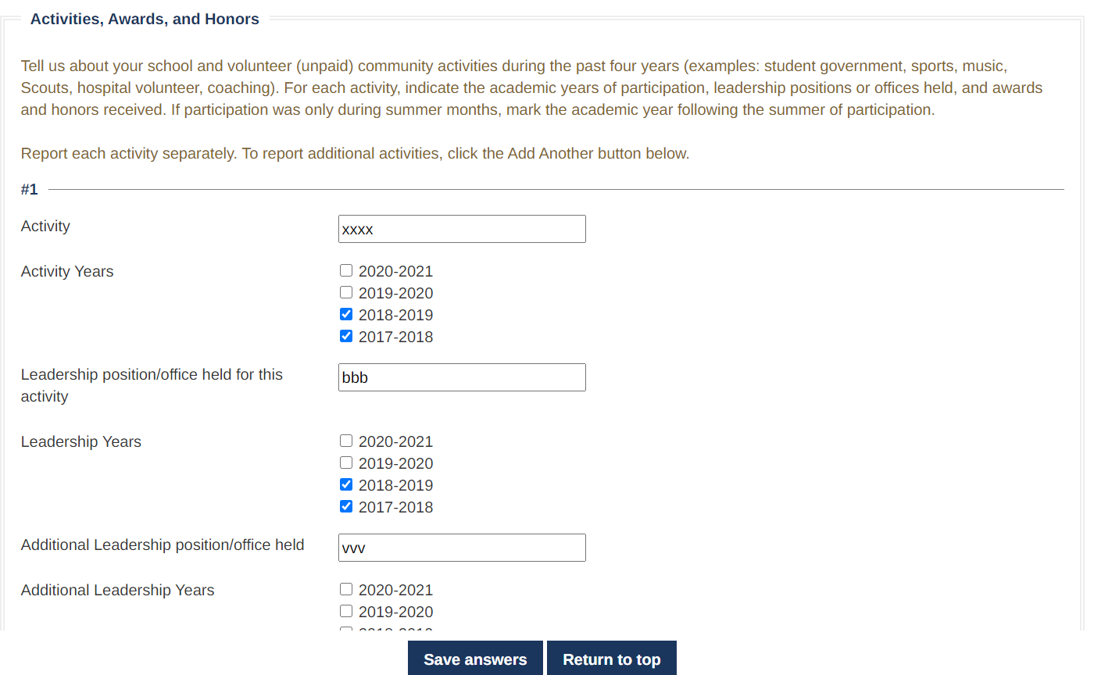

**Essays**

* The next two questions are essays. Follow the instructions. You can write whatever you want up to 1000 characters.

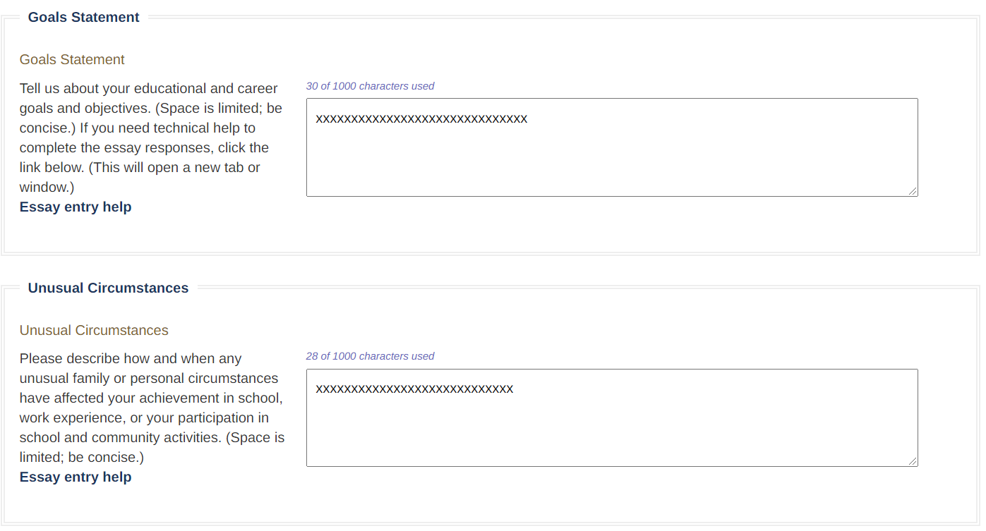

**Signature Page**

* Enter the full name of the student and the employee in the appropriate boxes. Enter the date you complete the application.

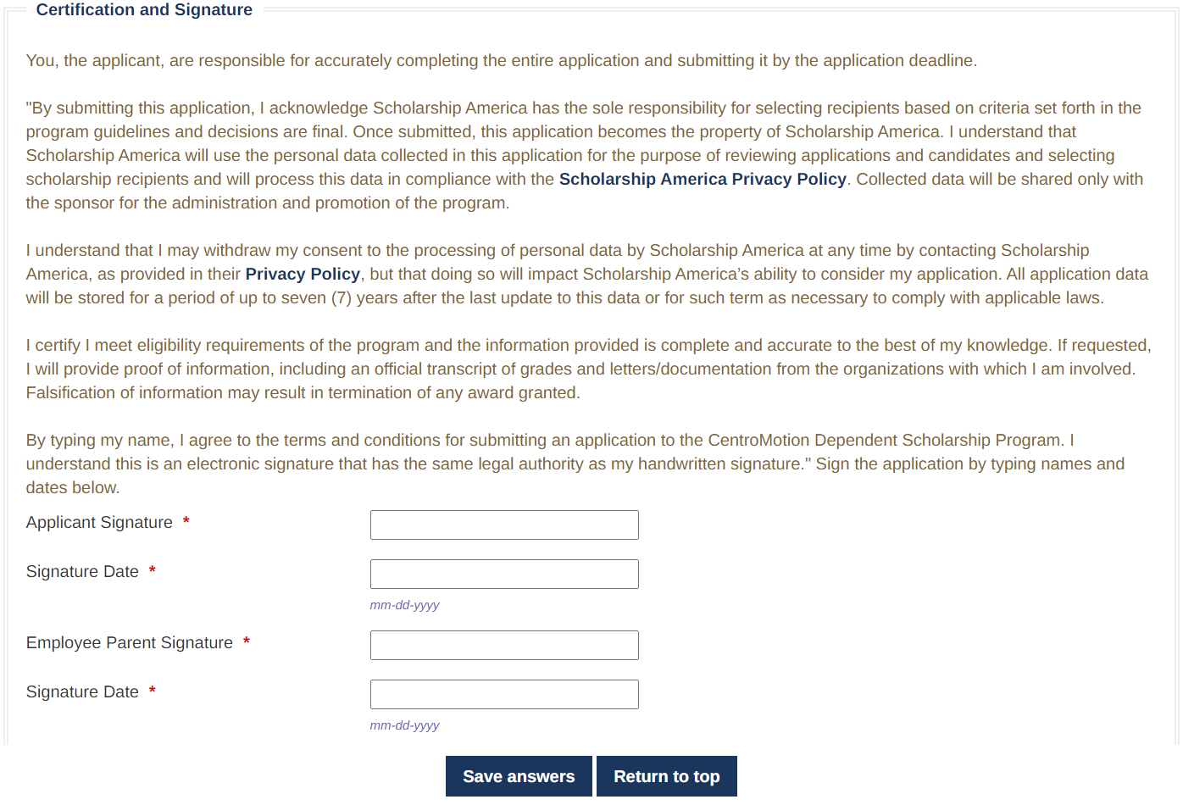

After completing this section, you must click Review and review your application for missing answers or errors. If all questions are answered, you can submit the application.

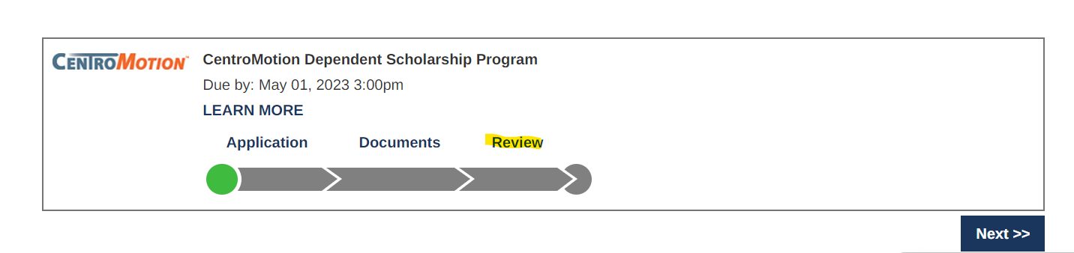

**If you have questions, you can contact Scholarship America at 001-507-931-1682 and refer to the CentroMotion Dependent Scholarship Program or email** centromotion@scholarshipamerica.org**.**